Mortality Investigation Report 62 Cattle exported by sea to Mexico in April 2016

Summary
On 27 April 2016, Landmark Operations Pty Ltd (Landmark) exported a consignment of breeder cattle by sea from Portland to Mazatlan in Mexico. The voyage took 23 days.
The consignment consisted of 6677 cattle, there were 155 mortalities reported, giving a mortality rate of 2.32 per cent. This exceeds the reportable mortality level of one per cent for cattle on voyages of more than ten days duration as prescribed by the Australian Standards for the Export of Livestock (ASEL).
Bovine Respiratory Disease (BRD) was the main factor contributing to the mortalities. Of the 104 cattle mortalities on the vessel, 102 were caused by BRD and two as a result of bloat. During discharge from the vessel a further 16 cattle died with BRD and 35 were euthanised for animal welfare reasons. The euthanised animals included four with lameness and 31 with chronic conditions due to BRD.

Information reviewed
The department investigated the mortalities by reviewing the following information:
- report from the exporter
- end of voyage report, daily voyage reports and additional information from the ship board Australian Government Accredited Veterinarian (AAV) who accompanied the consignment on board the vessel
- documents from the Australian Government Accredited Veterinarian (AAV) who prepared the consignment
- report from the Master of the vessel
- documents from the regional department veterinary officer (DVO)
- records from the registered premises
- load plans
- department records from previous and subsequent voyages.

Background
Since the introduction of ASEL in 2005, there have been no previous reportable mortality incidents recorded for cattle exported to Mexico. There has been only one consignment of breeder cattle exported to Mexico since 2008, which is the subject of this assessment.

Investigation findings

The Livestock
Cattle in the consignment consisted of 6571 breeder heifers and 106 bulls with an average weight of 290 and 430 kg respectively and ranging in age between the 8 to 18 months. The majority of these cattle were a mix of Angus, Hereford and Jersey breeds and their crosses.

Preparation in the registered premises
Cattle were prepared at one registered premises in Portland, Victoria and arrived there over a five day period leading to the start of isolation on 6 April 2016 for a period of 21 days. These cattle were sourced from 61 properties. Animals were treated in accordance with importing country requirements under the direction of the Australian Government Accredited Veterinarian (AAV). This included one vaccine for Infectious Bovine Rhinotracheitis Virus (Bovine Herpes Virus type1) and Mannheimia haemolytica with Bovilis MH + IBR® as per the importing country requirements.
During the isolation period, 105 different animals were treated for a variety of different conditions including BRD, lameness and pinkeye. A total of 51 animals treated for BRD were sourced from multiple properties.
During the final week of the isolation period, the cattle were yarded and drafted multiple times for selection. The exporter reported the selection process was complicated due to the involvement of multiple importers.
Three official Mexican government veterinarians inspected the cattle during isolation. A final health and welfare inspection of the cattle was conducted by the DVO along with the AAV on 26 April 2016. A total of 170 cattle were rejected due to various health conditions including pink eye, ring worm, lameness, BRD and other miscellaneous ailments. Twelve out of 170 rejects were affected by BRD. All other animals were assessed as fit to export.
A shipboard AAV, a Mexican government veterinarian and two experienced Australian stockmen were on board the vessel.

Conditions during the voyage
Fodder and water were loaded in accordance with ASEL requirements and the vessel departed Portland on 27 April 2016 under good weather conditions. On days 6, 7 and 8 the vessel experienced rough seas, high winds and rain. There was flooding of the forward decks caused by waves breaking over the bow of the ship. The on-board stockmen informed the exporter that the open decks suffered significant water coverage and were difficult to keep dry throughout this period.
The mortality data shows that after the period of poor weather (days 6 to 8) the number of mortalities began to increase significantly. The vessel experienced further inclement weather on day 18 which was followed by another spike in mortalities prior to discharge as shown in graph 1 below.

Graph 1: Ship mortalities during the voyage
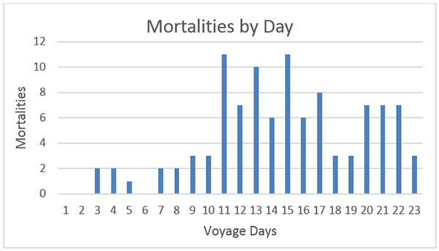
As shown in graph 2 the majority of mortalities (87 percent) occurred on the four open decks (deck 5, 6, 7 and 8) and first enclosed deck (deck 4) of the vessel. These decks were the most adversely affected by the rough weather experienced in the early part of the voyage.

Graph 2: Mortalities by deck
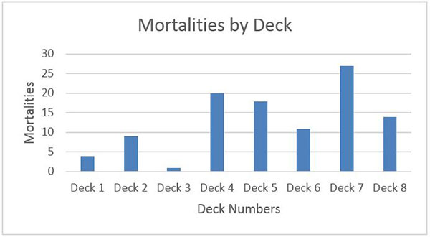

Mortalities and treatments
The AAV reported a range of clinical signs among the smaller Angus and Angus cross cattle including purulent nasal discharge, ‘stretched’ neck posture, rapid weight loss, isolation, dehydration and inappetence. Throughout the voyage, cattle identified as showing signs of BRD and lameness were isolated and treated with antibiotics and anti-inflammatories.
Daily voyage reports from the shipboard AAV detail mortalities and treatments (see Table 1). :
Day | Daily  Mortalities | Cumulative  Mortality | Cumulative  Mortality % | Mortality cause | Treatments
0 - 2 | 0 | 0 | 0.00 | Nil mortality
3 | 2 | 2 | 0.03 | BRD | BRD – 3 animals
4 | 2 | 4 | 0.06 | BRD | BRD – 3 animals
5 | 1 | 5 | 0.07 | BRD | BRD – 16 animals
6 | 0 | 5 | 0.07 | Nil mortality | BRD – 16 animals  Lameness – 2 animals
7 | 2 | 7 | 0.10 | BRD | BRD – 16 animals  Lameness – 2 animals
8 | 2 | 9 | 0.13 | BRD | BRD – 16 animals  Lameness – 2 animals
9 | 3 | 12 | 0.18 | BRD | BRD – 16 animals  Lameness – 1 animal
10 | 3 | 15 | 0.22 | BRD | BRD – 27 animals  Lameness – 1 animal
11 | 11 | 26 | 0.39 | BRD | BRD – 27 animals  Lameness – 1 animal
12 | 7 | 33 | 0.49 | BRD | BRD – 27 animals  Lameness – 1 animal
13 | 10 | 43 | 0.64 | BRD | BRD – 27 animals  Lameness – 3 animal
14 | 6 | 49 | 0.73 | BRD – five  Bloat - one | BRD – 35 animals  Lameness – 3 animal
15 | 11 | 60 | 0.90 | BRD – ten  Bloat - one | BRD – 35 animals  Lameness – 3 animals
16 | 6 | 66 | 0.99 | BRD | BRD – 35 animals  Lameness – 3 animals
17 | 8 | 74 | 1.11 | BRD | BRD – 35 animals  Lameness – 3 animal
18 | 3 | 77 | 1.15 | BRD | BRD – 35 animals  Lameness – 3 animal
19 | 3 | 80 | 1.20 | BRD | BRD – 35 animals  Lameness – 3 animal
20 | 7 | 87 | 1.30 | BRD | BRD – 35 animals  Lameness – 3 animal
21 | 7 | 94 | 1.41 | BRD | BRD – 40 animals  Lameness – 5 animals
22 | 7 | 101 | 1.51 | BRD | BRD – 40 animals  Lameness – 5 animals  40 animals recovered after treatment
23 | 3 | 104 | 1.56 | BRD | BRD – 40 animals  Lameness – 5 animals  40 animals recovered after treatment
Discharge | 51 | 155 | 2.32 | BRD – 16  Euthanised - 35  (4 – lameness  31 – BRD symptoms) | Animals deemed unfit to be unloaded and unlikely to survive by the AAV were euthanised for animal welfare reasons.

Australian Maritime and Safety Authority evaluation of the vessel
The vessel did not return to Australia until September 2017 when AMSA conducted their investigation. They concluded that all livestock services were operating satisfactorily during the voyage. There was no evidence noted to indicate the high mortalities were due to the vessel's non-compliance with Marine Order 43.
Since this voyage the vessel has only completed one other voyage in September 2017. The consignment consisted of feeder cattle exported from Townsville to Indonesia and the voyage was completed in 11 days. The mortality rate on this voyage was 0.15 per cent.

Exporter' actions
The exporter’s livestock operations manager travelled to Mexico to manage the discharge of the animals. As advised by the exporter’s consultant veterinarian, the exporter purchased additional medication and distributed to the destination farms to treat any animals showing signs of ill health upon arrival in Mexico. The exporter’s consultant also provided recommendations to the importer and clients for the ongoing management of the cattle.
After reviewing this voyage the exporter considers the handling of the cattle during the five to six days before export was a contributing factor in the BRD outbreak during the voyage.
The exporter engaged the services of five consultant veterinarians to devise a strategy on shipment preparation and on board disease mitigation. These recommendations were incorporated into a ‘High Risk Cattle Health Management Plan’.
The strategies in the High Risk Cattle Health Management Plan include:
- Reduced handling during preparation in the registered premises to minimise the stress on more susceptible cattle.
- Giving two IBR vaccinations to cattle during the quarantine period or one on farm prior to arrival at quarantine and the second in quarantine. Alternatively where protocol and practicalities allow a single shot live IBR vaccine may be used.
- Pre-departure and on board medicated fodder (chlortetracycline) to prevent BRD.
- Use of virucidal disinfectant as broadcast mist via pressurised misting machines used on board.
- Use of alternative bedding options including dust extracted wood shavings (saw dust was used as bedding material in this voyage).
Landmark will apply this plan to their future high risk shipments. This document has been included in the exporter’s Approved Arrangement manual and will be audited by the department.

