Independent Observer summary report on MV Girolando Express

Cattle exported to Vietnam in June 2022
December 2022

Voyage summary
Livestock: 2,679 cattle.
Vessel: MV Girolando Express.
Loading location and date: Darwin, 23 June 2022.
Vessel departure date: Darwin, 23 June 2022.
Discharge location and dates: Hon La, Vietnam, from 1 to 2 July 2022.
Voyage length: 10 days.
Independent Observer: Boarded at Darwin and remained onboard until completion of discharge.
Voyage mortality rate: 0.04% (1 mortality). This mortality is unlikely to be linked to any systemic failure by the exporter.
Notifiable mortality rate required to trigger a full investigation: 0.5% or 3 animals (whichever is greater).

Summary of observations
This report summarises key observations of the implementation and effectiveness of exporter arrangements to ensure the health and welfare of livestock. The report has been approved by the observer who accompanied the voyage.

Exporter documentation
The observer reported no issues regarding exporter documentation.

Loading
Based on observations made during this voyage, the exporter arrangements during loading were appropriate and effective in managing livestock health and welfare.

Personnel
Based on observations made during this voyage, the exporter arrangements relating to personnel were appropriate and effective in managing livestock health and welfare.

Daily routine
Based on observations made during this voyage, the exporter arrangements relating to daily routine were appropriate and effective in managing livestock health and welfare.

Feed and water
Based on observations made during this voyage, the exporter arrangements relating to feed and water were appropriate and effective in managing livestock health and welfare.

Ventilation
Based on observations made during this voyage, the exporter arrangements relating to ventilation were appropriate and effective in managing livestock health and welfare.

Pen conditions
Based on observations made during this voyage, the exporter arrangements relating to pen conditions were appropriate and effective in managing livestock health and welfare.

Health and welfare
- Four cattle were placed in hospital pens during the voyage for treatment. The stockperson reported treating for lameness, bloat, nasal discharge and difficulty breathing.
- On 30 June 2022, a bull previously treated for breathing difficulties was found deceased.

Discharge
Based on observations made during this voyage, the exporter arrangements during discharge were appropriate and effective in managing livestock health and welfare.

Department actions
No adverse animal health and welfare outcomes arising from exporter arrangements were observed. No regulatory action was taken.

Representative photographs of voyage
Day 2 Cattle in pen — no issues identified  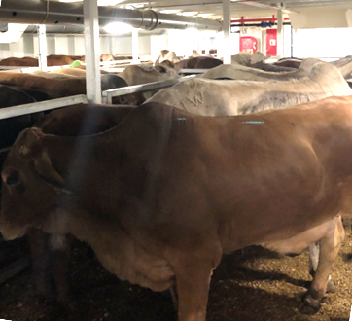 | Day 3 Cattle in pen — no issues identified  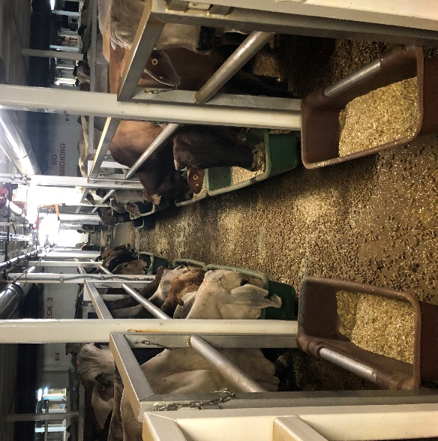
Day 5 Cattle in pen — no issues identified  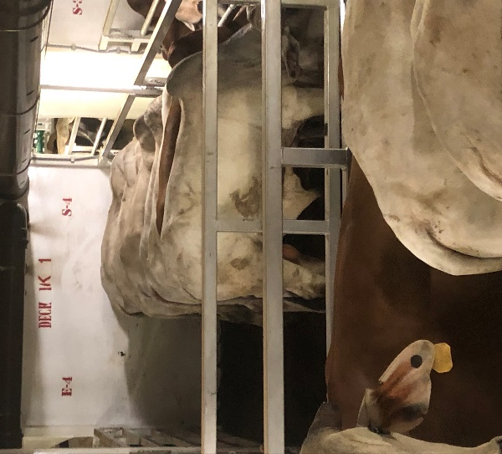 | Day 6 Cattle in pen — no issues identified  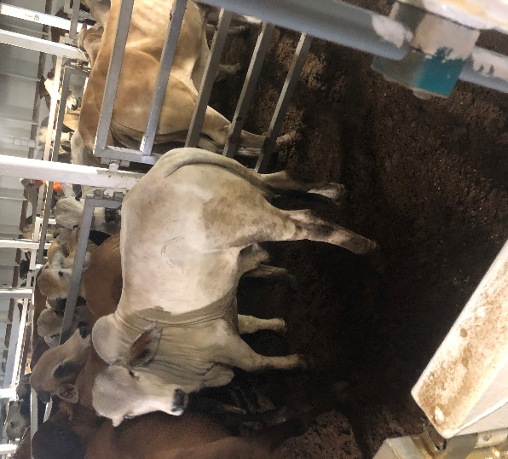
Day 8 Cattle in pen — no issues identified  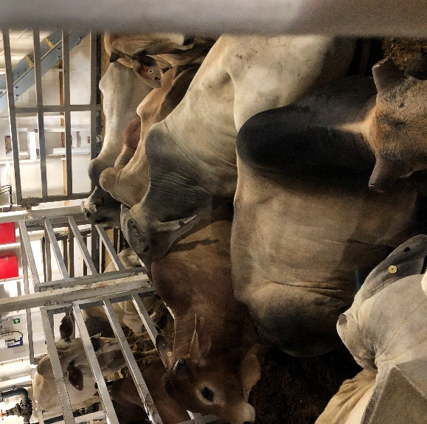 | Day 9 Cattle in pen — no issues identified  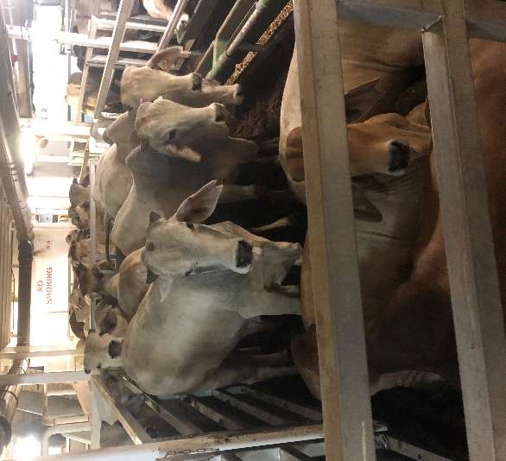
Acknowledgement of Country
We acknowledge the Traditional Custodians of Australia and their continuing connection to land and sea, waters, environment and community. We pay our respects to the Traditional Custodians of the lands we live and work on, their culture, and their Elders past and present.
© Commonwealth of Australia 2022
Unless otherwise noted, copyright (and any other intellectual property rights) in this publication is owned by the Commonwealth of Australia (referred to as the Commonwealth).
All material in this publication is licensed under a Creative Commons Attribution 4.0 International Licence except content supplied by third parties, logos and the Commonwealth Coat of Arms.
The Australian Government acting through the Department of Agriculture, Fisheries and Forestry has exercised due care and skill in preparing and compiling the information and data in this publication. Notwithstanding, the Department of Agriculture, Fisheries and Forestry, its employees and advisers disclaim all liability, including liability for negligence and for any loss, damage, injury, expense or cost incurred by any person as a result of accessing, using or relying on any of the information or data in this publication to the maximum extent permitted by law.

