Mortality Investigation Report 69 Sheep exported by sea to Kuwait, Qatar and the United Arab Emirates in August 2017

Summary
This report was first published on the department’s website on 29 March 2018. On 3 April 2018, Animals Australia met with the department to show excerpts of videos taken on five voyages of the Awassi Express which sailed to the Middle East between May and October 2017, including this voyage.
All five voyages included Emanuel Exports Pty Ltd (Emanuel) consignments, and two voyages included EMS Rural Exports Pty Ltd (EMS) consignments.
Animals Australia then made a formal complaint to the department on 5 April 2018 which included photographs and video footage from the five voyages. The complaint concerned whether the exporter managed the welfare of the sheep during the voyages, and in accordance with the Australian Standards for the Export of Livestock (ASEL).
A comprehensive review of this information has been conducted. Mortality Report 69 has been updated to reflect the outcomes of this review. Updated text is provided in bold.
The information, provided by Animals Australia about this voyage, eight months after the voyage occurred, demonstrated the department’s original conclusion the exporter complied with the Export Control (Animals) Order (the Orders) and ASEL was incorrect.
Emanuel loaded a consignment of 63,804 sheep and 50 cattle which was exported by sea from Fremantle on 1 August 2017 to Qatar, Kuwait and United Arab Emirates (UAE). Unloading was completed on 17, 19 and 24 August 2017 respectively.
A mortality rate of 3.76 per cent (2,400 sheep out of 63,804) was recorded for this voyage in the Master’s Report Carriage of Livestock as required by Marine Orders part 43 under subsection 425 (1AA) of the Navigation Act 1912. This exceeds the reportable mortality level of 2 per cent as prescribed by ASEL. The majority of the mortalities were caused by heat stress. No cattle mortalities were recorded on the voyage.
There was a discrepancy of 195 sheep on the final unload count in the UAE. The Masters report recorded 24,000 sheep were unloaded whereas the shore count recorded by the Australian Accredited Veterinarian (AAV) was 23,805. However, the AAV left the vessel before all sheep were unloaded at the final port of discharge.¹
AMSA conducted an independent investigation into this reportable mortality and concluded that all livestock services on the ship were operating satisfactorily during the voyage.
Actions taken on board the ship to mitigate the heat stress event commenced prior to the forecast severe weather conditions in the Gulf of Oman. Extra crew were rostered on to undertake additional housekeeping and to prioritise watering to hand watered troughs. Some excessively boggy pens and those in hotter areas were opened to allow sheep access to alleyways. Some pens were joined by closing of cross ship alleyways.
When high heat and humidity started to affect sheep, individual animals identified as heat affected or bogged were removed into alleyways near ventilators. Livestock were further spread out across the vessel as more space became available following discharge at each port.
The department required Emanuel to comply with a heat stress management plan for their next consignment to the Middle East using the same vessel. That consignment was exported in September 2017. The heat stress management plan outlined risk mitigation strategies for all stages of export, including providing 10 per cent additional space to that prescribed in ASEL. The voyage recorded a mortality rate of 0.52 per cent (310 out of 59 823 sheep); below the reportable level of 2 per cent. Videos and photographs from this voyage were part of evidence provided to the department by Animals Australia. The videos showed that poor animal welfare management also occurred on this voyage, even though mortalities were relatively low.
¹ This information was provided in the Animals Australia’s report and confirmed by the department.

Information review
The department reviewed the following information in the course of the original investigation between December 2017 and March 2018:
- email correspondence from the exporter
- pre-export documentation, including, application for export permit and health certificate, export permit, health certificate, exporter livestock consignment report
- documents related to preparation and loading including Email correspondence with the inspecting departmental veterinary officer and the ‘rejection of livestock from an export consignment’ and the ‘veterinarian declaration for the health and welfare of export stock’ forms
- heat stress risk assessment (HSRA – HotStuff) from the exporter
- load plan from the exporter
- daily voyage reports from the AAV
- report from the Master of the vessel
- end of voyage report from the AAV
- email correspondence from AMSA
- mortality report from the exporter
- Bureau of Meteorology climate data
- records from the previous and subsequent Emanuel consignments of sheep to the Middle East including the Heat Risk Management Plan (HRMP).
- the Report to Parliament – Livestock mortalities for export by sea
- note to file discussion with shipboard AAV.
The department comprehensively reviewed the additional information provided by Animals Australia on 5 April 2018 included 320 video files and photographs taken during the five voyages. Of these, 79 were taken during this voyage (see Table 1).

Background
In the five years before this incident, there have been three other reportable mortality incidents for sheep exported to the Middle East, Report #46 (August 2013), Report #65 (July 2016) and Report #66 (August 2016). Heat stress was a contributing factor in all cases.
The department requires exporters to minimise the risks associated with heat stress on voyages to the Middle East during the high risk months of May to October. ASEL specifies standards for livestock export and this includes a requirement that sheep must have less than 25mm of wool and heavier sheep (above 50kg) be provided with additional space during the high risk months. Exporters must also complete and comply with a HSRA (HotStuff) for each consignment, specific for the vessel undertaking the voyage.
The HotStuff model was developed for the Australian livestock export industry to estimate and minimise the incidence of heat stress mortality in livestock during voyages to the Middle East. The model integrates animal characteristics (breed, weight, sex, age etc.), vessel design and ventilation characteristics, and climate estimates (along routes and at destination ports). Inputs from these factors are loaded into the model and are used to adjust (increase) the ASEL space allocation for voyages.

Investigation Findings

The livestock
The consignment consisted of lambs, wethers, ewes and rams. There were multiple breeds represented, including Merino, Damara and crossbred (Dorper) sheep and lambs. All lines were destined for slaughter.

Preparation in the Registered Premises
Sheep were received at the registered premises (RP) from 22 to 25 July 2017. In total 69,686 sheep were received with 59,686 housed in sheds and the balance held in paddocks.
No sheep were recorded as dead on arrival. There were no health or welfare issues identified during preparation of this consignment and no treatments were required.
Pellet feed was provided of the type used aboard the livestock export ship. Sheep were either delivered bare shorn, or shorn at the RP in preparation for export.
During the isolation period at the RP, 31 natural mortalities were recorded representing 0.04 per cent of the sheep. Post mortems were not conducted.
The weather was mild, records from the Bureau of Meteorology in Mardella recorded temperatures ranging from a minimum of 6.3 degrees Celsius to a maximum of 21.4 degrees Celsius with light rain on most days during pre-export preparation.
The sheep were inspected by an AAV on 31 July and 1 August 2017 and by the Departmental Veterinary Officer (DVO) on 30 July 2017. The sheep were deemed fit for export, with the exception of the animals that had been rejected.
A total of 63,804 sheep were loaded onto the vessel. Of the approximately 5000 head remaining at the RP, stock were either retained for the next shipment, or sold as not being suitable for export.
In the Heat Stress Risk Assessment submitted to department for the voyage, all sheep were described as being shorn to less than 10mm. The videos showed some sheep had wool greater than 10mm. Additionally, some sheep had untipped outward turning horns resulting in a risk of harm to other animals in breach of ASEL standards. This demonstrated that the exporters’ selection and AAV inspection processes were not effective at removing unsuitable animals.

The Vessel
The vessel has ten single tier decks (lowest to uppermost Decks F, E, D, C, B, A 1, 2, 3, and 4) that are fully enclosed. Ventilation is provided mechanically with input and exhaust fans.
Pens on decks A to F were manually supplied with water using hoses, whereas decks 1 to 4 had automatic watering arrangements, supplemented with additional manual watering as needed (e.g. through the use of empty feed troughs as water troughs).

Loading of the vessel
Loading of the 63,804 sheep, assessed as fit for export by the AAV and DVO, was conducted on 31 July and 1 August 2017 in Fremantle. The exporter provided a record of ‘rejection of livestock from an export consignment’ and the ‘veterinarian declaration for the health and welfare of export stock’. No injuries or mortalities were recorded during loading.

Conditions during the Journey
Voyages to the Middle East require an AAV and a LiveCorp accredited stock person on board. The AAV is responsible for managing livestock health and welfare and reporting to the department and works closely with the stock person, master of the vessel and ship’s crew.
The AAV reported that feeding was done by hand with pellets twice daily with some lines of sheep receiving extra top ups. The daily average daily intake was 1.6kg per head which is greater than ASEL requirements. All sheep had access to feed and constant monitoring of sheep behaviour and gut fill indicated all sheep had adequate feed. Water was provided by a combination of automatic systems with additional troughs filled manually, decks 1 to 4 and manually to decks A to F. The AAV reported that the crew scheduling was effective in ensuring adequate supply and access to water was available over the voyage. During the last week of the voyage, when temperatures increased, daily intake went from 5 to 7 litres per animal and extra crew and shifts were rostered to maintain supply.
The AAV daily report for day 14 indicated the deck condition score as 3 in some areas (requiring cleaning; boggy). Other areas were rated 2 (sticky) and some 1 (ok). This pattern was maintained until day 18 when the AAV indicated pens were drying and the discharge of sheep in Kuwait allowed remaining sheep to be moved into the drier areas and were further spread out as the ship made for UAE.
On route (day 14) to Port Hamad, Qatar the AAV first recorded severe high temperatures, humidity and heat affected sheep. High temperatures and humidity were reported overnight on day 15 and 16 while at Port Hamad with less humidity contributing to improved conditions during the day. The vessel discharged 25 000 sheep at Qatar (39.2 percent of sheep loaded) allowing further spreading out of remaining animals. On day 17, the AAV reported heat stress conditions overnight whilst underway to Kuwait. On day 18 the heat stress assessment dropped to moderate and this level was maintained for the remainder of the voyage.
The AAV recorded scores for heat stress and deck condition are represented in graph 1.

Graph 1: Deck condition during voyage (maximum reported)
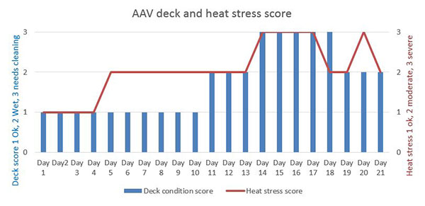
The AAV reported, decks that were less densely stocked (A, F and much of decks 1 and B) ‘held up better’. The AAV reported this was possibly due to less respiration and urine contributing to local humidity. Graph 2 shows that there are some variations between decks in the 11:00 am wet bulb temperature readings².

Graph 2: Temperature by deck
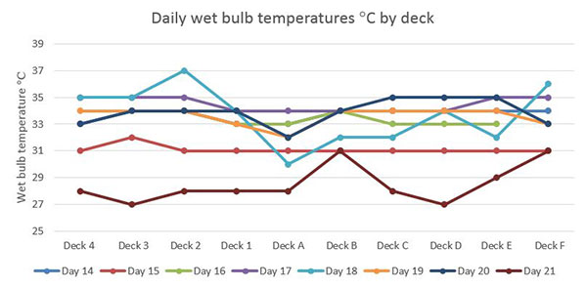
² An increase in wet bulb temperature demonstrates a rise in relative humidity, whereas dry bulb reflects a rise in ambient air temperature. A combination of elevated wet and dry bulb temperatures significantly increases the risk of heat stress in animals.

Mortalities and treatments
The AAV reported that the hospital pens were set up and housed a maximum of 187 sheep during the voyage. The cases were mainly enteritis with some injuries and infected claw cases. Enteritis cases were provided with chaff and treated with Alamycin. Hospitalised sheep represented only a small percentage (0.29 per cent) of the sheep loaded and most of these animals recovered. There were also cases of pneumonia, primarily in Dorper sheep. Pinkeye was treated with over-the-counter medication and Orbenin ointment where identified.
The AAV’s daily and end of voyage reports reported a total of 11 ewes lambed on the voyage (0.42 per cent of ewes loaded) producing 12 lambs. A number of these ewes and lambs were observed in video files provided by Animals Australia. The department considered the fact that a small percentage of ewes lambed not to be a breach of ASEL bearing in mind the relatively small number, and that it is consistent with the level of error expected when pregnancy testing. The main issues for the department related to the lack of suitable and timely aftercare provided to the lambs and ewes, with several lambs observed in the video footage dead in pens and alleys following failure to identify and remove ewes and lambs to hospital pens.
The AAV reported that the cases of pneumonia mortalities in Dorper sheep started to accrue in the latter part of the voyage. These cases were however over taken by the sudden heat stress mortality event and the subsequent number of dead sheep. Restrictions on autopsies in port zones meant no new cases of pneumonia were confirmed.
Graph 3 represents daily report wet bulb temperature on each deck as an average and mortalities recorded. This reading is taken at 11:00 and does not necessarily represent the maximum wet bulb temperature on the vessel on that day. Note: extreme conditions were recorded on the evening of day 14 and the evening of day 15 and are detailed in comments in this section.

Graph 3: 11:00 Averaged deck wet bulb temperature recording and daily mortality
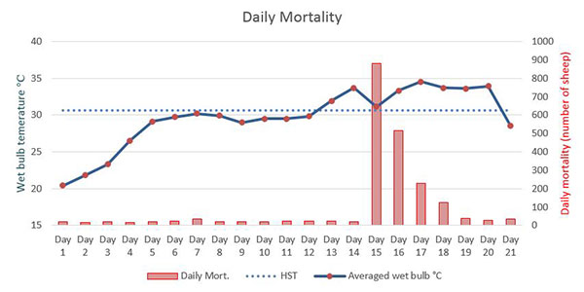
* Heat Stress Threshold (HST) The maximum ambient wet bulb temperature at which the heat balance of the deep body temperature can be controlled using available mechanisms of heat loss. Sheep (standard animal) 30.6 degrees C.
(Graph 3: mortalities from daily report day 21 - no correction for sheep count discrepancies or mortalities that occurred after the last daily report period)
The AAV recorded moderate heat stress was evident in some areas from day 5 till day 13 of the voyage. Daily reports record maximum wet bulb temperature ranged from 29.1 degrees Celsius to 31.9 degrees Celsius during this period. In McCarthy and Banhazi (2016) the report refers tofindings of an unpublished report McCarthy (2008 unpublished) that describes the negative impacts of extended periods of relatively high temperature and humidity with associated increase water intake and urination in sheep. This situation overwhelms the capacity for the ships ventilation to ‘lift’ moisture from the deck. When extreme temperature and humidity is experienced with these deck conditions already a problem, high mortalities will occur. The AAV also believes this is a factor in this reportable mortality.
On day 14 the AAV reported sheep with severe heat stress in some areas of the vessel as the ship was underway to Qatar. The AAV reported that sheep ‘were toughing it out’ and additional crew had been rostered on to undertake housekeeping duties and to prioritise watering to hand watered decks. The crew also worked to provide more space. Some excessively boggy pens and pens in hotter areas were opened to allow sheep access to alleyways. Some pens were also joined by closing of cross ship alleyways. These measures provide approximately 10 to 12 square metres of extra space per 4 pens however they could not be universally applied as the ‘loose’ sheep interfere with watering and can foul troughs.
The vessel arrived in Qatar late on day 14. On that night and the following night, the AAV reported that temperatures reached 36 degrees Celsius dry bulb and 35 degrees Celsius wet bulb with 94 per cent humidity. These extreme conditions lasted for approximately 5 to 6 hours each night. The AAV also noted that when these extreme conditions are encountered, large numbers of animals start to die. There were 880 recorded on day 15 and 517 mortalities recorded on day 16, all attributed to heat stress. The mortalities reached reportable level of 2 per cent on day 16 with 2.66 per cent cumulative total recorded on that day.
The AAV’s end of voyage report noted that a number deaths attributed to day 16 of the voyage may have actually occurred on the evening of day 15. It appears that these may not have been recorded until day 16 due to the increased workload on the crew when managing the heat stress event.
When high heat and humidity started to affect sheep, individual animals identified as heat affected or bogged were removed into alleyways and placed near ventilators and provided water. Livestock were further spread out as more space became available following discharge of 25 000 sheep at Qatar, and again after discharge of 12 404 sheep in Kuwait.
The AAV recorded that ventilation was working, however it can only deliver the outside air conditions to the decks. The AAV also commented that deck temperatures on fully loaded enclosed decks are usually a few degrees cooler (dry bulb) and a few degrees warmer (wet bulb) than outside temperatures.
Conditions eased during day 17. Mortalities for the remainder of the voyage were attributed to heat stroke and heat related conditions such as downer animals and pneumonia cases. As the vessel was mostly in port, no autopsies were completed to confirm pneumonia or other causes of death. There was a delay leaving Kuwait and the AAV reported this was beneficial for the sheep as it allowed the decks to dry out and it was a lower heat stress environment.

Graph 4: Mortalities percentages by deck
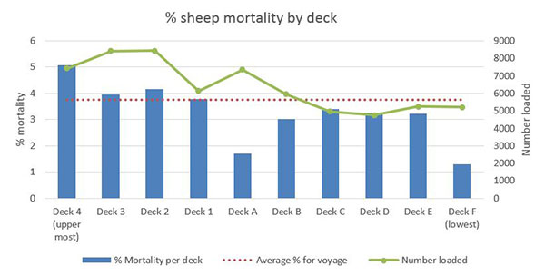
(Graph 4 deck mortalities from daily report day 21 - no correction for sheep count discrepancies or mortalities that occurred after the last daily report period)
Graph 4 shows that deck mortalities occurred on all decks with some significant variations.
All decks were fully loaded when the extreme heat stress conditions were encountered. Decks 2 and F recorded the highest wet bulb temperatures (see Graph 2), however Graph 4 shows that mortalities on these decks were just above average or significantly lower than average. The numbers loaded are included in the graph to show that the decks with more sheep influenced the overall average.
The AAV commented that less densely loaded decks (A, F and much of decks 1 and B) ‘held up better’ and this observation is supported by the figures with the exception of deck 1, that recorded close to the average mortality percentage.

Graph 5: Average sheep weight by deck and mortality rate per cent.
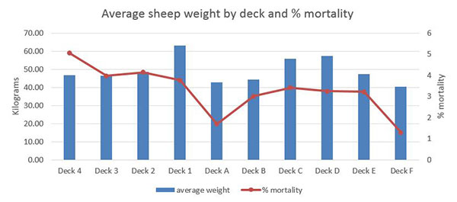
(Graph 5 figures loaded sheep from HSRA and deck mortality from daily report day 21 - no correction for sheep count discrepancies or mortalities that occurred after the last daily report period)
Graph 5 shows mortality as a percentage and the average sheep weight on each deck. This average was applied with some decks housing multiple classes and others exclusively one class. Deck 4 was loaded exclusively with young wethers (46.75 kg) and suffered a high percentage of mortalities, deck ‘A’ housed 85.5 per cent lambs (ranging from 38.73kg to 49.26kg) and 14.5 percent heavier wethers (53.53 to 69.43 kg) and suffered lower than average mortalities. Deck F was exclusively lambs (40.51 kg) and had the lowest mortalities. The AAV believes the age of the sheep rather than the weight may be the contributing factor in mortality trends however these are generally related.
In Ferguson et.al (2008) the weight of sheep is recognised as a contributing factor in heat related mortalities, whilst calling for more research to provide reliable data.
In Graph 6, the percentage mortality line demonstrates that generally the lighter animals (on left) fared better than heavier sheep (on right). The mortality number per class is included as it indicates which classes contributed the most to the overall mortality figure of 2400.

Graph 6: Class and weight of sheep by mortality
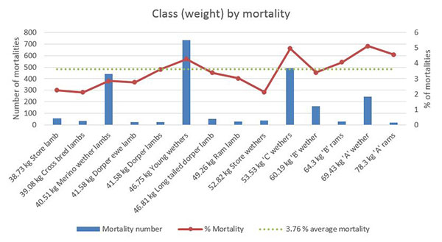
(Graph 6 figures loaded sheep from HSRA and deck mortality from daily report day 21 - no correction for sheep count discrepancies or mortalities that occurred after the last daily report period)
This graph also shows that despite the susceptibility of heavier sheep and greater resilience in lighter sheep, all classes exceed the reportable rate of two per cent when exposed to these severe weather conditions.
Information provided by Animals Australia on 5 April 2018:
Department officers reviewed the photographic and video evidence provided by Animals Australia. The metadata was analysed by the department and were confirmed to have been taken on the dates reported.
Of the 320 videos provided to the department, 79 were taken on this voyage. Of those, the majority (40 per cent) were taken during the heat stress event i.e. days 15 – 18. The majority of the videos were taken overnight.

Table 1: Number of files provided by Animals Australia by voyage.
Voyage # (departure date) | 23L  (9 May 2017) | 24L  (21 June 2017) | 25L  (2 Aug 2017) | 26L  (13 Sept 2017) | 27L  (26 Oct 2017)
# of files | 83 | 54 | 79 | 66 | 38
% of files | 25.9 | 16.9 | 24.7 | 20.6 | 11.9
Corresponding with the time leading up to, during and immediately after the heat stress event a number of animal welfare concerns were observed e.g. carcases were not removed from pens. The department accepts that due to the extreme weather conditions experienced at that time a number of these concerns were not addressed by the accredited stockman, the accredited veterinarian or the vessel crew as they were focused on managing the welfare of the majority of the livestock on board the vessel.
From the information and videos provided, the department identified the following issues:
- pens and manure pads in very poor condition due to the extreme weather conditions compounding the heat stress experienced by the livestock
- inadequate/no management of ewes and lambs
- sick, recumbent and injured sheep not treated and/or euthanased in a timely manner
- non-compliance with the Heat Stress Risk Assessment (HSRA) required under ASEL – wool length in a small percentage of sheep was not in compliance with the HSRA submitted for the voyages with some sheep observed to have had a wool length greater than 10mm
- inadequate access to water and suitable feed due to corpses obstructing trough access
- a small percentage of sheep with untipped outward facing horns causing a risk of harm to other animals
- the accredited stockperson and the accredited veterinarian departed the vessel before all livestock were discharged at the final port of discharge.
In addition to the video files provided for this voyage (Voyage 25L), Animals Australia provided material taken on four other voyages on the Awassi Express (see Table 1 above). None of these voyages experienced reportable mortality levels, however similar animal welfare concerns were observed even though the extreme heat stress conditions of Voyage 25L were not encountered.
The major issues observed across the other voyages related to the on-board management of the animals and pens. These included examples of:
- pens which had deteriorated to unacceptable levels resulting in sheep being bogged in faecal pads
- the non-treatment of animals requiring immediate treatment or euthanasia
- poor care of lambs born during the voyages, and
- empty feed and water troughs.
In addition, some sheep with wool lengths longer than stated in the HSRA and untipped horns were also observed.
That the vessel had several decks serviced by a manual watering system was considered to be a factor in the poor pen conditions. Interviews conducted by the department identified the night crew was inexperienced with livestock handling and management, which may have contributed to a lack of actions taken to address issues and provide or obtain treatment for animals needing assistance or euthanasia.
Taken together, the five voyages demonstrated the exporters’ oversight of their on-board management strategies was inadequate and ineffective in identifying and addressing the issues observed.
Apart from the matters outlined above, the stocking density on all five voyages appeared tight, not providing sufficient room for animals to rest adequately. No evidence was found to indicate more animals were loaded onto the vessel than that set out in the HSRA and export permit.

Australian Maritime and Safety Authority evaluation of the vessel
AMSA provided their investigation findings on the Awassi Express to the department on 9 March 2018. They verified that they checked all areas of compliance with Marine Order 43 including logbooks, reports and records on board relating to the voyage. There was no evidence that the vessel or master had failed to comply with MO43 at any time livestock were on board.

Exporters Actions
In the lead up to the heat event, extra crew were rostered on and tasked with ensuring provision of water to the sheep was given priority.
More space was provided prior to the heat event by giving sheep, where possible, access to walk ways. As sheep were unloaded the remaining sheep were moved when possible, into vacated drier pens to provide them with the most space possible.

Conclusions
Both the Master and AAV reported a mortality rate of 3.76 per cent for this consignment of sheep exported to the Middle East.
The cause of this reportable mortality was heat stress. The peak in mortalities corresponded with extreme heat and humidity experienced in Qatar. The humidity and temperatures experienced from day 5 to day 13 and associated deck conditions, prior to arrival in Qatar is likely to have contributed to the severity of the mortality event. The highest mortality rates were in the ‘A’ class wethers (69.43 kg), which were the fourth most numerous class of the sheep on board the ship making up 7.51 per cent of the consignment. There was no significant correlation of mortalities with deck position.
The department’s original investigation found the sheep were prepared and transported in accordance with the Orders and ASEL based on the information provided to the department during the course of the investigation. The additional material provided by Animals Australia in April 2018 revealed some breaches of ASEL relating to stock selection (S1.7 and S1.16(b)); preparation and loading (S4.12); and the on-board management of livestock and pens during the voyage (S5.6 and S5.7). That the animal welfare concerns and breaches were observed across the five voyages indicated broader issues with the exporters’ processes.
Following a show cause process, the department has subsequently cancelled the livestock export licence of Emanuel and of EMS—a wholly owned subsidiary company of Emanuel which also had consignments on voyages 23L and 27L.
In light of the new information provided on 5 April 2018, the following actions have been undertaken:
- Shortly after the video footage was received, Independent Observers were placed on all sheep voyages to the Middle East. Independent observers are being placed on voyages – and are reporting back to the regulator. This will move to address the major issue of exporter plans to manage animal welfare not being implemented or reported effectively.
- Additional space was required on all voyages to the Middle East—17.5 per cent greater than that required by the ASEL—until the McCarthy review was finalised (see below).
- The Minister announced an immediate review of conditions for the export of sheep to the Middle East during the northern hemisphere summer (May to October) to protect their welfare. The review was undertaken by Dr Michael McCarthy, an experienced shipboard veterinarian, who reported his findings and recommendations to the Minister in May 2018.
- All 23 recommendations from the McCarthy Review were supported by the department. Full details on the review and the department’s response are available on the department’s website.
- One of Dr McCarthy’s recommendations was the change of the heat stress risk assessment model from one based on mortalities, to one based on animal welfare. The HSRA review commenced in August and is under consultation at the time of publishing.
- The department implemented recommendations from the McCarthy review through directions under the Australian Meat and Live-stock Industry Act 1997 and Export Control (Animals) Order 2004 to require greater space for sheep travelling by sea to the Middle East using an allometric stocking density. This has greatly reduced stocking densities on voyages during the northern summer (May to October). Reports received from independent observers indicate that all sheep can now rest in pens at the same time.
Other important changes include that:
- all vessels travelling to the Middle East must have their ventilation characteristics independently verified
- bedding is loaded on sheep voyages to the Middle East for use in managing unsatisfactory pen conditions
- where Kuwait is a destination port, it be the vessel’s first port of unloading, and
- the reportable mortality level for sheep be reduced from two per cent to one per cent.
- The Minister also announced the ASEL review would complete its work by the end of 2018, rather than 2019. Information regarding the ASEL review is available on the department’s website.
- For voyages carrying live sheep to the Middle East (including through the Persian Gulf and Red Sea), each animal will have 17.5 per cent more space than currently required by the ASEL from 1 November 2018 until implementation of the revised ASEL.

Appendix 1: Summary of daily mortalities from daily reports
Day of voyage | Daily mortalities (number of sheep) | Cause of daily mortalities recorded by the AAV | Cumulative mortalities (number of sheep)
1 | 18 | 15 Enteritis; 3 Injury | 18
2 | 17 | 9 Enteritis; 8 Unrecorded | 35
3 | 21 | 13 Enteritis; 1 Septicaemia / Misadventure; 1 Septicaemia; 6 unrecorded | 56
4 | 17 | 13 Enteritis; 1 Injury; 3 unrecorded | 73
5 | 20 | 20 Enteritis | 93
6 | 23 | 23 Enteritis | 116
7 | 35 | 35 Enteritis | 151
8 | 19 | 17 enteritis; 2 Misadventure | 170
9 | 20 | 17 Enteritis; 2 Pneumonia; 2 Unrecorded | 190
10 | 21 | 17 Enteritis; 3 Pneumonia; 1 Unrecorded | 211
11 | 23 | 23 Enteritis | 234
12 | 23 | 17 Enteritis; 3 Pneumonia; 1 Unrecorded; 1 Septicaemia | 257
13 | 23 | 28 Enteritis; 3 Pneumonia; 1 Septicaemia; 1 Injury | 280
14 | 20 | 16 Enteritis; 4 Pneumonia | 300
15* | 880 | 880 Heat Stroke or Heat related | 1180
16** | 517 | 517 Heat Stroke or Heat related | 1697
17 | 227 | Mainly Heat Stroke or Heat related | 1924
18 | 126 | Mainly Heat Stroke or Heat related | 2050
19 | 40 | Mainly Heat Stroke or Heat related consequences downer animals and Pneumonia (no autopsies as in port) | 2090
20 | 29 | Mainly Heat Stroke or Heat related consequences downer animals and Pneumonia (no autopsies as in port) | 2119
21 | 35 | Mainly Heat Stroke or Heat related consequences including downer animals | 2154
22 | 12 | Mainly Heat related consequences including downer animals | 2166
23 | 234 | Mainly Heat related consequences including downer animals | 2400
(Appendix 1: from daily report day 21 - no correction for sheep count discrepancies or mortalities that occurred after the last daily report period)
* Arrived in Qatar, Port of Hamad 02:15 16 August 2017
** Departed Qatar, Port of Hamad 15:15 17 August 2017

References
Live Export, Project LIVE.116. Developing of a heat stress risk management model, Maunsell Australia Pty td, Published by Meat & Livestock Australia Ltd December 2003
Ferguson D, Fisher A, White B, Casey R and Mayer B 2008 Review of the Livestock Export Heat Stress Risk assessment Model (Hotstuff)
Meat and Livestock Australia, final report W.LIV.0290, McCarthy and Banhazi, 2016 Published by Meat and Livestock Australia Limited

