Mortality Investigation Report 69 Sheep exported by sea to Qatar, Kuwait and United Arab Emirates in August 2017

Summary
Emanuel Exports Pty Ltd (Emanuel) loaded a consignment of 63,804 sheep and 50 cattle that was exported by sea from Fremantle on 1 August 2017 to Qatar, Kuwait and United Arab Emirates (UAE). Unloading was completed on 17, 19 and 24 August 2017 respectively.
A mortality rate of 3.76 per cent (2,400 sheep out of 63,804) was recorded for this voyage in the Master’s Report Carriage of Livestock as required by Marine Orders part 43 under subsection 425 (1AA) of the Navigation Act 1912. This exceeds the reportable mortality level of 2 per cent as prescribed by the Australian Standards for the Export of Livestock (ASEL). The majority of the mortalities were caused by heat stress. No cattle mortalities were recorded on the voyage.
There was a discrepancy of 195 sheep on the final unload count in the UAE. The Masters report recorded 24,000 sheep were unloaded whereas the shore count recorded by the Australian Accredited Veterinarian (AAV) was 23,805. Sheep counts are undertaken manually and the source of the actual error is not possible to determine. If all 195 sheep were added to the reported mortalities, the rate would have been 3.79 per cent.
AMSA conducted an independent investigation into this reportable mortality and concluded that all livestock services on the ship were operating satisfactorily during the voyage.
Actions taken on board the ship to mitigate the heat stress event commenced prior to the forecast severe weather conditions in the Gulf of Oman. Extra crew were rostered on to undertake additional housekeeping and to prioritise watering to hand watered troughs. Some excessively boggy pens and those in hotter areas were opened to allow sheep access to alleyways. Some pens were joined by closing of cross ship alleyways.
When high heat and humidity started to affect sheep, individual animals identified as heat affected or bogged were removed into alleyways near ventilators. Livestock was further spread out across the vessel as more space became available following discharge at each port. These actions however, were insufficient to prevent the reportable mortality incident.
The department required Emanuel to comply with a heat stress management plan for their next consignment to the Middle East using the same vessel, that consignment was exported in September 2017. This document outlined risk mitigation strategies for all stages of export, including a 10 per cent reduction in stocking density (to that prescribed in ASEL). The voyage recorded a mortality rate 0.52 per cent; this is below the reportable level of 2 per cent.
The department’s investigation found the sheep were prepared and transported in accordance with Export Control (Animals) Order 2004 and the Australian Standards for the Export of Livestock (Version 2.3) 2011 (ASEL). The department is considering a revised Heat Risk Management Plan from Emanuel to address the risks associated with consignments exported to the Middle East during the hottest months (July/August). These changes will be implemented in 2018.

Information review
The department reviewed the following information in the course of the investigation:
- email correspondence from the exporter
- pre-export documentation, including, application for export permit and health certificate, export permit, health certificate, exporter livestock consignment report
- documents related to preparation and loading including Email correspondence with the inspecting departmental veterinary officer and the rejection of livestock from an export consignment and the veterinarian declaration for the health and welfare of export stock forms
- heat stress risk assessment (HSRA – HotStuff) from the exporter
- load plan from the exporter
- daily voyage reports from the AAV
- report from the Master of the vessel
- end of voyage report from the AAV
- email correspondence from AMSA
- mortality report from the exporter
- Bureau of Meteorology climate data
- records from the previous and subsequent Emanuel consignments of sheep to the Middle East including the Heat Risk Management Plan (HRMP).
- the Report to Parliament – Livestock mortalities for export by sea
- note to file discussion with shipboard AAV.

Background
In the five years before this incident there have been three other reportable mortality incidents for sheep exported to the Middle East, report # 46 (August 2013), report 65 (July 2016) and report 66 (August 2016). These voyages were all undertaken during the northern hemisphere summer and heat stress was a contributing factor in all cases.
The department requires exporters to minimise the risks associated with heat stress on voyages to the Middle East during the high risk months of May to October. ASEL specifies standards for livestock export and this includes a requirement that sheep must have less than 25mm of wool and heavier sheep (above 50kg) be provided with additional space during the high risk months. Exporters must also complete and comply with a HSRA (HotStuff) for each consignment, specific for the vessel undertaking the voyage.
The HotStuff model was developed for the Australian livestock export industry to estimate and minimise the incidence of heat stress mortality in livestock during voyages to the Middle East. The model integrates animal physiology, vessel design and climate estimates (along routes and at destination ports). Inputs from these factors are loaded into the model and are used to estimate the probability of heat stress and mortality occurring (Ferguson et.al. 2008). Hotstuff is currently under review by Livecorp.

Investigation Findings

The livestock
The consignment consisted of lambs, wethers, ewes and rams. There were multiple breeds represented, including Merino, Damara and crossbred sheep and lambs. All lines were destined for slaughter.

Preparation in the Registered Premises
Sheep were received at the registered premises (RP) from the 22 to 25 July 2017. In total 69,686 sheep were received with 59,686 housed in sheds and the balance held in paddocks.
No sheep were recorded as dead on arrival. There were no health or welfare issues identified during preparation of this consignment and no treatments were required.
Pellet feed was provided of the type used aboard the livestock export ship. Sheep were either delivered bare shorn, or shorn at the RP in preparation for export.
During the isolation period at the RP, 31 natural mortalities were recorded representing 0.04 per cent of the sheep. Post mortems were not conducted.
The weather was mild, records from the Bureau of Meteorology in Mardella recorded temperatures ranging from a minimum of 6.3 degrees Celsius to a maximum of 21.4 degrees Celsius with light rain on most days during pre-export preparation.
The sheep were inspected by an AAV on 31 July and 1 August 2017 and by the Departmental Veterinary Officer (DVO) on 30 July 2017. The sheep were deemed fit for export, with the exception of the animals that had been rejected (see Table 1 below).
A total of 63,804 sheep were loaded onto the vessel. Of the approximately 5000 head remaining at the RP, stock were either retained for the next shipment, or sold as not being suitable for export.

The Vessel
The vessel has ten single tier decks (lowest to uppermost Decks F, E, D, C, B, A 1, 2, 3, and 4) that are fully enclosed. Ventilation is provided mechanically with input and exhaust fans in compliance with AMSA requirements.

Loading of the vessel
Loading of the 63,804 sheep, assessed as fit for export by the AAV and DVO, was conducted on 31 July and 1 August 2017 in Fremantle. The exporter provided a record of rejection of livestock from an export consignment and the veterinarian declaration for the health and welfare of export stock. No injuries or mortalities were recorded during loading.
The HSRA load calculation for the voyage was compared to the ASEL standard requirements for minimum pen area per head for sheep and goats exported by sea. All minimum pen area standards were met.

Conditions during the journey
Voyages to the Middle East require an AAV and a LiveCorp accredited stock person on board. The AAV is responsible for managing livestock health and welfare and reporting to the department and works closely with the stock person, master of the vessel and ship’s crew.
The AAV reported that feeding was done by hand with pellets twice daily with some lines of sheep receiving extra top ups. The daily average daily intake was 1.6kg per head which is greater than ASEL requirements. All sheep had access to feed and constant monitoring of sheep behaviour and gut fill indicated all sheep had adequate feed. Water was provided by a combination of automatic systems with additional troughs filled manually, decks 1 to 4 and manually to decks A to F. The AAV reported that the crew scheduling was effective in ensuring adequate supply and access to water was available over the voyage. During the last week of the voyage, when temperatures increased, daily intake went from 5 to 7 litres per animal and extra crew and shifts were rostered to maintain supply.
The AAV daily report for day 14 indicated the decks condition score as 3 in some areas (requiring cleaning boggy). Other areas were still rated 2 (sticky) and some 1 (ok). This pattern was maintained until day 18 when the AAV indicated pens were drying and the discharge of sheep in Kuwait allowed remaining sheep to be moved into the drier areas and were further spread out as the ship made for UAE.
On route (day 14) to Port Hamad, Qatar the AAV first recorded severe high temperatures, humidity and heat affected sheep. High temperatures and humidity were reported overnight on day 15 and 16 while at Port Hamad with less humidity contributing to improved conditions during the day. On day 17 the AAV reported heat stress conditions overnight whilst underway to Kuwait. On day 18 the heat stress assessment dropped to moderate and this was the maximum recorded for the remainder of the voyage.
The AAV recorded scores for heat stress and deck condition are represented in graph 1.

Graph 1: Deck condition during voyage (maximum reported)
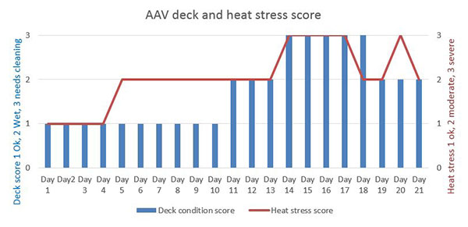
All decks were loaded in accordance with ASEL requirements and HSRA recommendations. The AAV reported, decks that were less densely stocked (A, F and much of decks 1 and B) ‘held up better’. The AAV reported this was possibly due to less respiration and urine contributing to local humidity. Graph 2 shows that there are some variations between decks in the 11:00 am wet bulb temperature readings.

Graph 2: Temperature by deck
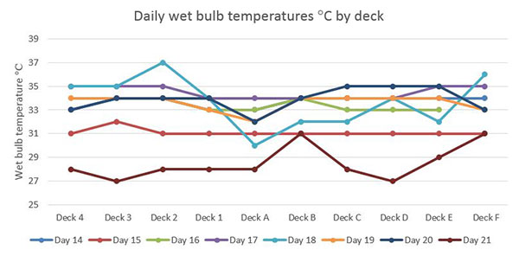

Mortalities and treatments
The AAV reported that the hospital pens were set up and housed a maximum of approximately 187 sheep during the voyage. The cases were mainly enteritis with some injuries and infected claw cases. Enteritis cases were provided with chaff and treated with Alamycin. The approximately 187 sheep represented only a small percentage, 0.29 per cent of the sheep loaded and most of these animals recovered. There were also cases of pneumonia, primarily in Dorper sheep. Pinkeye was treated with over the counter medication and Orbenin ointment where found.
The AAV reported that the cases of pneumonia mortalities in Dorper sheep started to accrue in the latter part of the voyage. These cases were however over taken by the sudden heat stress mortality event and the subsequent number of dead sheep. Restrictions on autopsies in port zones meant no new cases of pneumonia were confirmed.
Graph 3 represents daily report wet bulb temperature on each deck as an average and mortalities recorded. This reading is taken at 11:00 and does not necessarily represent the maximum wet bulb temperature on the vessel on that day. Note: extreme conditions were recorded on the evening of day 14 and the evening of day 15 and are detailed in comments in this section.

Graph 3: 11:00 Averaged deck wet bulb temperature recording and daily mortality
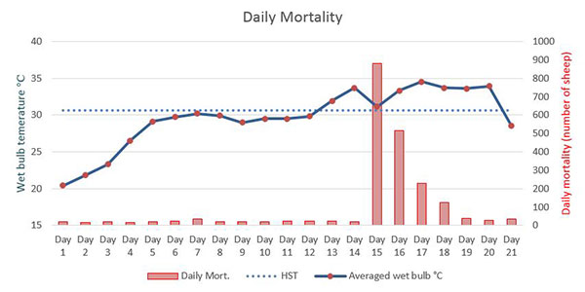
* Heat Stress Threshold (HST) The maximum ambient wet bulb temperature at which the heat balance of the deep body temperature can be controlled using available mechanisms of heat loss. Sheep (standard animal) 30.6 degrees C.
(Graph 3: mortalities from daily report day 21 - no correction for sheep count discrepancies or mortalities that occurred after the last daily report period)
The AAV recorded moderate heat stress was evident in some areas from day 5 till day 13 of the voyage. Daily reports record maximum wet bulb temperature ranged from 29.1 degrees Celsius to 31.9 degrees Celsius during this period. In McCarthy and Banhazi (2016) the report refers tofindings of an unpublished report McCarthy (2008 unpublished) that describes the negative impacts of extended periods of relatively high temperature and humidity with associated increase water intake and urination in sheep. This situation overwhelms the capacity for the ships ventilation to ‘lift’ moisture from the deck. When extreme temperature and humidity is experienced with these deck conditions already a problem, high mortalities will occur. The AAV also believes this is a factor in this reportable mortality.
On day 14 the AAV reported sheep with severe heat stress in some areas of the vessel as the ship was underway to Qatar. The AAV reported that sheep ‘were toughing it out’ and additional crew had been rostered on to undertake housekeeping duties and to prioritise watering to hand watered decks. The crew also worked to provide more space. Some excessively boggy pens and pens in hotter areas were opened to allow sheep access to alleyways. Some pens were also joined by closing of cross ship alleyways. These measures provide approximately 10 to 12 square metres of extra space per 4 pens however they could not be universally applied as the ‘loose’ sheep interfere with watering and can foul troughs.
The vessel arrived in Qatar late on day 14. On that night and the following night, the AAV reported that temperatures reached 36 degrees Celsius dry bulb and 35 degrees Celsius wet bulb with 94 per cent humidity. These extreme conditions lasted for approximately 5 to 6 hours each night. The AAV also noted that when these extreme conditions are encountered, large numbers of animals will to start to die. There were 880 recorded on day 15 and 517 mortalities recorded on day 16, all attributed to heat stress. The mortalities reached reportable level of 2 per cent on day 16 with 2.66 per cent cumulative total recorded on that day.
When high heat and humidity started to affect sheep, individual animals identified as heat affected or bogged were removed into alleyways and placed near ventilators and provided water. Livestock were further spread out as more space became available following discharge at Qatar and again after discharge in Kuwait.
The AAV recorded that ventilation was working, however it can only deliver the outside air conditions to the decks. The AAV also commented that deck temperatures on fully loaded enclosed decks are usually a few degrees cooler (dry bulb) and a few degrees warmer (wet bulb) than outside temperatures.
Conditions eased during day 17. Mortalities for the remainder of the voyage were attributed to heat stroke and heat related conditions such as downer animals and pneumonia cases. As the vessel was mostly in port, no autopsies were completed to confirm pneumonia or other causes of death. There was a delay leaving Kuwait and the AAV reported this was beneficial for the sheep as it allowed the decks to dry out and it was a lower heat stress environment.

Graph 4: Mortalities percentages by deck
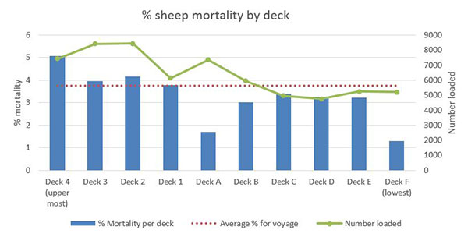
(Graph 4 deck mortalities from daily report day 21 - no correction for sheep count discrepancies or mortalities that occurred after the last daily report period)
Graph 4 shows that deck mortalities occurred on all decks with some significant variations.
All decks were still fully loaded when the extreme heat stress conditions were encountered. The AAV did not provide evidence or comments that indicate particular decks were more severely impacted by the extreme heat. Decks F and two recorded the highest wet bulb temperatures (see Graph 2), however Graph 4 shows that mortalities on these decks were just above average or significantly lower than average. The numbers loaded are included in the graph to show that the decks with more sheep influenced the overall average.
The AAV did comment that less densely loaded decks (A, F and much of decks 1 and B) ‘held up better’ and this observation is supported by the figures with the exception of deck 1, that recorded close to the average mortality percentage.

Graph 5: Average sheep weight by deck and mortality rate per cent.
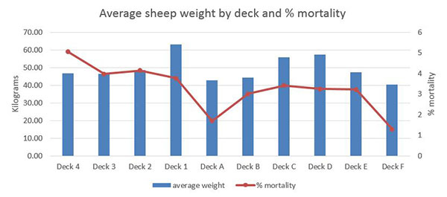
(Graph 5 figures loaded sheep from HSRA and deck mortality from daily report day 21 - no correction for sheep count discrepancies or mortalities that occurred after the last daily report period)
Graph 5 shows mortality as a percentage and the average sheep weight on each deck. This average was applied with some decks housing multiple classes and others exclusively one class. Deck 4 was loaded exclusively with young wethers (46.75 kg) and suffered a high percentage of mortalities, deck ‘A’ housed 85.5 per cent lambs (ranging from 38.73kg to 49.26kg) and 14.5 percent heavier wethers (53.53 to 69.43 kg) and suffered lower than average mortalities. Deck F was exclusively lambs (40.51 kg) and had the lowest mortalities. The AAV believes the age of the sheep rather than the weight may be the contributing factor in mortality trends however these are generally related.

Graph 6: Class and weight of sheep by mortality
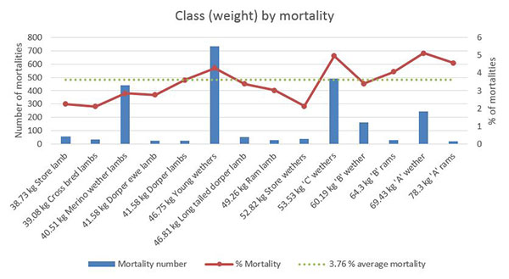
(Graph 6 figures loaded sheep from HSRA and deck mortality from daily report day 21 - no correction for sheep count discrepancies or mortalities that occurred after the last daily report period)
In Ferguson et.al (2008) the weight of sheep is recognised as a contributing factor in heat related mortalities, whilst calling for more research to provide reliable data.
In Graph 6, the percentage mortality line demonstrates that generally the lighter animals (on left) fared better than heavier sheep (on right). The mortality number per class is included as it indicates which classes contributed the most to the overall mortality figure of 2400.
This graph also shows that despite the susceptibility of heavier sheep and greater resilience in lighter sheep, all classes exceed the reportable rate of two per cent when exposed to these severe weather conditions.

Australian Maritime and Safety Authority Evaluation of the Vessel
AMSA provided their investigation findings to the department on 9 March 2018. They verified that they checked all areas of compliance with Marine Order 43 including logbooks, reports and records on board relating to the voyage. There was no evidence that the vessel or master had failed to comply with MO43 at any time livestock were on board.

Exporters Actions
The animals were loaded in accordance with ASEL and the HSRA.
In the lead up to the heat event, extra crew were rostered on and tasked with ensuring provision of water to the sheep was given priority.
More space was provided prior to the heat event by giving sheep, where possible, access to walk ways. As sheep were unloaded the remaining sheep were moved when possible, into vacated drier pens to provide them with the most space possible.

Conclusions
Both the Master and AAV reported a mortality rate of 3.76 per cent for this consignment of sheep exported to the Middle East.
The department found the sheep were prepared and transported in accordance with Export Control (Animals) Order 2004 and the Australian Standards for the Export of Livestock (Version 2.3) 2011 (ASEL).
The cause of this reportable mortality was heat stress. The peak in mortalities corresponded with extreme heat and humidity experienced in Qatar. The humidity and temperatures experienced from day 5 to day 13 and associated deck conditions, prior to arrival in Qatar is likely to have contributed to the severity of the mortality event. The highest mortality rates were in the ‘A’ class wethers (69.43 kg), which were the fourth most numerous class of the sheep on board the ship making up 7.51 per cent of the consignment. There was no significant correlation of mortalities with deck position.
The department required Emanuel to review and comply with a heat event management plan for their next consignment of sheep exported to the Middle East using the same vessel and the mortality rate for this voyage (0.52 per cent) was below the reportable level.
The department is considering a revised Heat Risk Management Plan from Emanuel to address the risks associated with consignments exported to the Middle East during the hottest months (July/August). These changes will be implemented in 2018.

Appendix 1: Summary of daily mortalities from daily reports
Day of voyage | Daily mortalities (number of sheep) | Cause of daily mortalities recorded by the AAV | Cumulative mortalities (number of sheep)
1 | 18 | 15 Enteritis; 3 Injury | 18
2 | 17 | 9 Enteritis; 8 Unrecorded | 35
3 | 21 | 13 Enteritis; 1 Septicaemia / Misadventure; 1 Septicaemia; 6 unrecorded | 56
4 | 17 | 13 Enteritis; 1 Injury; 3 unrecorded | 73
5 | 20 | 20 Enteritis | 93
6 | 23 | 23 Enteritis | 116
7 | 35 | 35 Enteritis | 151
8 | 19 | 17 enteritis; 2 Misadventure | 170
9 | 20 | 17 Enteritis; 2 Pneumonia; 2 Unrecorded | 190
10 | 21 | 17 Enteritis; 3 Pneumonia; 1 Unrecorded | 211
11 | 23 | 23 Enteritis | 234
12 | 23 | 17 Enteritis; 3 Pneumonia; 1 Unrecorded; 1 Septicaemia | 257
13 | 23 | 28 Enteritis; 3 Pneumonia; 1 Septicaemia; 1 Injury | 280
14 | 20 | 16 Enteritis; 4 Pneumonia | 300
15* | 880 | 880 Heat Stroke or Heat related | 1180
16** | 517 | 517 Heat Stroke or Heat related | 1697
17 | 227 | Mainly Heat Stroke or Heat related | 1924
18 | 126 | Mainly Heat Stroke or Heat related | 2050
19 | 40 | Mainly Heat Stroke or Heat related consequences downer animals and Pneumonia (no autopsies as in port) | 2090
20 | 29 | Mainly Heat Stroke or Heat related consequences downer animals and Pneumonia (no autopsies as in port) | 2119
21 | 35 | Mainly Heat Stroke or Heat related consequences including downer animals | 2154
(Appendix 1: from daily report day 21 - no correction for sheep count discrepancies or mortalities that occurred after the last daily report period)
* Arrived in Qatar, Port of Hamad 02:15 16 August 2017
** Departed Qatar, Port of Hamad 15:15 17 August 2017

References
Live Export, Project LIVE.116. Developing of a heat stress risk management model, Maunsell Australia Pty td, Published by Meat & Livestock Australia Ltd December 2003
Ferguson D, Fisher A, White B, Casey R and Mayer B 2008 Review of the Livestock Export Heat Stress Risk assessment Model (Hotstuff)
Meat and Livestock Australia, final report W.LIV.0290, McCarthy and Banhazi, 2016 Published by Meat and Livestock Australia Limited
​

