Mortality Investigation Report 66 Sheep exported by sea to Oman and Kuwait in August 2016

Summary
A vessel carrying 60 112 sheep was loaded in Adelaide and Fremantle on 14 and 20 August 2016¹ respectively.
The voyage carried four consignments prepared by two exporters. Emanuel Exports Pty Ltd (Emanuel) and Central Pacific Pty Ltd (CenPac) each loaded a consignment in both Adelaide and Fremantle.
The voyage discharged in Oman and Kuwait on 4 and 8 September 2016 respectively. Both Cenpac consignments unloaded in Oman, Emanuel's consignments unloaded in Oman and Kuwait.
The Australian Standards for the Export of Livestock (Version 2.3) April 2011 (ASEL) requires mortality rates to be reported to the department at a consignment level. The mortalities for the voyage and consignments were as follows:
- Voyage: 748 mortalities out of 60 112 loaded (1.24 per cent mortality)
- Consignment A: Emanuel - Adelaide to Oman and Kuwait: 386 mortalities out of 17 917 loaded (2.15 per cent mortality)
- Consignment B: Central Pacific - Adelaide to Oman: 93 mortalities from 15 000 loaded (0.62 per cent mortality)
- Consignment C: Emanuel - Fremantle to Oman and Kuwait: 227 mortalities from 24 955 loaded (0.91 per cent mortality)
- Consignment D: Central Pacific - Fremantle to Oman: 42 mortalities from 2 240 loaded (1.88 per cent mortality)
The reportable mortality level for sheep exported by sea prescribed under ASEL for this voyage was 2 per cent². The voyage reported a 1.24 per cent mortality rate and did not exceed the 2 per cent reportable level. However, Consignment A reported mortalities of 2.15 per cent.
This report details the investigation into the reportable mortality event encountered by Consignment A.
The on-board Australian Government Accredited Veterinarian (AAV) reported that heat stress was the main cause of the high mortalities. Very hot and humid weather was encountered on day 22 of the voyage between the ports of Muscat in Oman and Shuwaikh in Kuwait. Concurrent [VALE NOTE : this sentence is incomplete in the report].
Until day 22, mortalities in Consignment A ranged between 0 and 7 per day. The consignment mortality rate on day 21 was 0.37 per cent. Mortalities rose to 27 on day 22, coinciding with the onset of very hot and humid weather. There were 192 mortalities recorded on day 23, 49 on day 24, and 47 on day 25 (the final day of the voyage). The consignment's voyage mortality rate was 2.12 per cent. The mature A class wethers experienced the highest mortality rate in Consignment A, with a voyage mortality rate of 7.44 per cent. The young B line wethers were the next highest mortality class in the consignment, at 1.94 per cent, followed by the young A line wethers (1.34 per cent), and the mature B line wethers (0.74 per cent).
¹ The length of time taken to publish this report was due to operational oversight (which has subsequently been addressed), and the decision to delay publication enabling concurrent publishing with Report 69.
² The reportable level for sheep was amended to require exporters to report at one per cent on 7 July 2018.

Information review
The department reviewed the following information in the course of the investigation:
- email correspondence from the exporter
- pre-export documentation, including export permit, health certificate and Approved Export Program
- documents relating to preparation and loading, including declaration of welfare and supervision of loading of livestock, record of rejection of livestock from an export consignment, and email correspondence with the inspecting departmental veterinary officer (DVO)
- heat stress risk assessment (HSRA - Hotstuff) from the exporter
- load plans from the exporter
- consolidated livestock export consignment report for the consignment from the DVO
- email correspondence from AMSA and public records of vessel detentions
- report from the master of the vessel
- daily voyage reports from the Australian Government Accredited Veterinarian (AAV)
- end of voyage report from the AAV
- mortality report from the exporter
- note to file discussion with shipboard AAV
- records from the previous and subsequent Emanuel consignments of sheep to the Middle East including the heat stress management plan
- Bureau of Meteorology climate data
- the Report to Parliament - Livestock mortalities for export by sea – 2011-2016.

Background
In the five years before this incident there were two other reportable mortality incidents for sheep exported to the Middle East: Report #46 (August 2013) and Report #65 (July 2016). Heat stress was a contributing factor in both cases.
The department requires exporters to minimise the risks associated with heat stress on voyages to the Middle East during the high risk months of May to October. ASEL specifies standards for livestock export and this includes a requirement that sheep must have less than 25mm of wool and heavier sheep (above 50kg) be provided with additional space during the high risk months. Exporters must also complete and comply with a HSRA (HotStuff) for each consignment, specific for the vessel undertaking the voyage.
The HotStuff model was developed for the Australian livestock export industry to estimate and minimise the incidence of heat stress mortality in livestock during voyages to the Middle East. The model integrates animal characteristics (breed, weight, sex, age etc.), vessel design and ventilation characteristics, and climate estimates (along routes and at destination ports). Inputs from these factors are loaded into the model and are used to adjust (increase) the ASEL space allocation for voyages. The model estimates the number of animals which can be safely loaded to provide a less than 2 per cent chance of a 5 per cent mortality event occurring.

Investigation Findings

The Livestock
The sheep in the consignment were merino wethers for slaughter as follows:
- 2,687 mature “A-line” merino wethers, average live weight 60.5kg
- 8,271 mature “B-line” merino wethers, average live weight 51.5kg
- 2,229 young “A-line” merino wethers, average live weight 50kg
- 4,730 young “B-line” merino wethers, average live weight 47kg.

Preparation in the registered premises
Consignments A and B were sourced by Emanuel and prepared at the same registered premises (RP) for export to Oman and Kuwait. The sheep were purchased from 67 different vendors, arrived at the RP between 5 and 8 August 2016, and were drafted into type and weight classes.
All sheep were recorded as new shorn to 10 mm in preparation for export in the HSRA submitted for the voyage.
The weather was mild, records from a Bureau of Meteorology station at Adelaide Airport recorded temperatures ranging from a minimum of 2.3 degrees Celsius to a maximum of 20.6 degrees Celsius.
During the isolation period at the RP, 17 natural mortalities were recorded representing 0.05 per cent of the sheep. Post mortems were not conducted.
Sheep were inspected by an AAV on 14 August and by a DVO on 13 and 14 August 2016. The sheep were deemed fit for export, with the exception of rejected sheep (see Table 1 below).

Table 1: Rejected sheep
Number of rejected sheep | Time of Rejection | Reason
163 | On arrival at feedlot | Predominately outside of commercial specification, some with scabby mouth, lameness, foot soreness and pink eye.
309 | During loadout to vessel | Predominately pinkeye, lameness, scours and scabby mouth. A small number were rejected for being outside of purchase specifications.
18 | Shipside | Reasons not recorded.

The Vessel
The vessel has ten single tier decks (lowest to uppermost Decks F, E, D, C, B, A 1, 2, 3, and 4) that are fully enclosed. Ventilation is provided mechanically with input and exhaust fans in compliance with AMSA requirements, with manual watering required on Decks A to F.

Loading onto the vessel
Consignment A loaded 15 917 sheep on 14 August 2016 in Adelaide. No injuries or mortalities were recorded during loading. The sheep were loaded onto Decks F, E, D and C. On 25 August 2016, 2 000 sheep from consignment B located on Deck 4 were transferred to Consignment A for commercial reasons, making the total 17 917. Certification documentation was reissued to reflect this. The sheep were loaded in accordance with the final HSRA and load plan.

Conditions during the journey
Voyages to the Middle East require an AAV and Live Corp accredited stock person on board. The AAV is responsible for managing livestock health and welfare and reporting to the department and works closely with the stock person, master of the vessel and ship’s crew. The AAV, stock people, master (and ship’s crew) receive voyage instructions from the exporter to manage the health and welfare of the sheep during the voyage.
Records show fodder (pellets and chaff) was loaded in excess of the ASEL requirements and distribution of fodder and water reported as effective by the AAV. The daily average intake for the start of the voyage was 1.2kg per head and from day seven 1.3kg. The intake when averaged for the voyage is greater than ASEL requirements for fodder provision. At voyage end, excess fodder remained and the AAV reported no problems with food distribution. The AAV did note the pelletised fodder contained some fragmented pellets during the first two weeks of the voyage however this improved after that period. Chaff was fed to lower decks between day 9 and day 17. The sheep consumed 6 to 6.4 litres of water per day, meeting the allowance when ambient temperature is expected to exceed 35°C.
The end of voyage report indicated the decks as very good, never wet or sloppy apart from hose leaks. The AAV daily reports for day 9 indicated the decks condition score as 1 - 2 (1: OK, 2: Wet). This pattern was maintained until day 19 when the AAV reported that decks were rated as 2 – 3 (3: Requires cleaning) with a comment that this was moist to wet. This rating was maintained till day 24 when the rating dropped to 1 -2 with a comment that decks were rapidly drying out.
The air quality was consistently reported as ‘good’ without significant smell of ammonia and no smell of hydrogen-sulphide detectable even when heat and humidity stress was evident in the sheep.
On day 19, the AAV first recorded temperatures rapidly increasing and many sheep open mouth breathing. The temperature and humidity continue to cause many sheep to mouth breath on day 20 and 21 at Port Muscat, Oman, where over 28 000 sheep were discharged (47 per cent). All sheep from the Cenpac consignments discharged in Oman (approximately 17 000) and approximately 11 000 sheep from the two Emanuel consignments. At day 21 of the voyage, the mortality rates for the two Adelaide consignments was 0.37 per cent for Consignment A and 0.62 per cent for Consignment B.
On route (day 22) to Kuwait at 11:00 the AAV recorded the highest standard daily temperatures of the voyage, with deck ranging from 34 to 35 degrees (wet bulb) and relative humidity recorded between 81 and 87 per cent.
On day 23 the AAV reported dry bulb temperatures reached 38 degrees overnight to midmorning (wet bulb temperature was not reported at that time). It was reported the wet bulb temperatures fell to 28 degrees later in the day with a rapid drop in humidity. The 11:00 readings for day 23 gave a wet bulb temperature range of 31 and 34 degrees with relative humidity ranging from 70 to 81 per cent.
The AAV reported during the final four days of the voyage it was difficult to reduce the temperature due to the outside condition despite the ventilation system working well and good air quality.
The AAV reported some variation in the wet bulb temperature and relative humidity between decks, however no deck was significantly hotter or more humid than any other during the heat event.

Graph 1: Temperature by deck
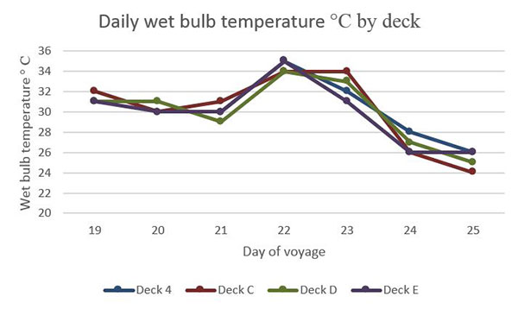

Mortalities and treatments
Some sheep were relocated into hospital pens commencing with four animals on Day 2 showing lameness. A maximum of 30 animals were recorded in the hospital pens receiving treatments, primarily for lameness with low numbers of pink eye and some skin lesions in new shorn young sheep. Scabby mouth was reported initially in two pens on Deck C and later in low numbers on all decks.
Early mortalities were reported as due to salmonella, enteritis, inanition or secondary inanition with some cases of misadventure as well as fatty liver and ketosis in fat animals. Heat stress was first reported in the stock on day 21 when unloading in Oman. At this time the cumulative mortality was 71 sheep, no sheep were hospitalised and no mortalities were reported from heat stress.
The AAV reported heat stress caused the abrupt increase in mortalities recorded on day 22. On day 23 to day 25 feed was removed from mature animals to alleviate heat stress complications and watering given priority. The AAV commented that most animals were not eating at this time.
The AAV comments on daily voyage reports relating to ‘fat’ sheep were investigated. Stock preparation records were obtained and further information sought from the AAV, departmental veterinarian and exporter representatives. The findings consistently indicated that references to ‘fat’ sheep are relative to the average body condition score of the sheep accepted for export and not an indication any specific animal was outside ASEL specifications. Departmental and exporter representatives were able to give assurances that overweight sheep were not loaded.
Graph 2 represents daily reported wet bulb temperature on each deck as an average and mortalities recorded. This reading is taken at 11:00 and does not necessarily represent the maximum wet bulb temperature on the vessel on that day. Note: extreme conditions were also recorded on the evening of day 21 and are detailed in comments in this section.
Details of daily mortalities are reported in Appendix 1.

Graph 2 – 11:00 Averaged deck wet bulb temperature recording and daily mortality (Consignment A)
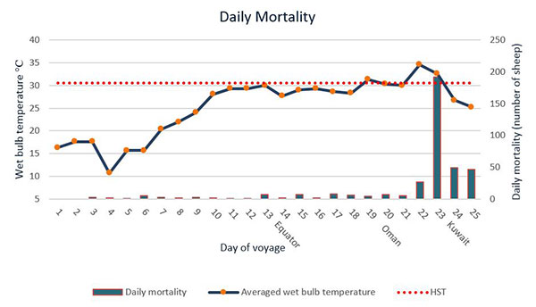
* Heat Stress Threshold (HST) The maximum ambient wet bulb temperature at which the heat balance of the deep body temperature can be controlled using available mechanisms of heat loss. Sheep (standard animal) 30.6 degrees C.
(Graph 2: mortalities from daily report day 25)
From day 22 to day 25 there was a rapid increase in daily mortalities recorded over four days (27, 192, 49, 47). The AAV attributed the 192 mortalities on day 23 to heat stress.

Graph 3 – Mortality numbers by class of sheep (Consignment A)
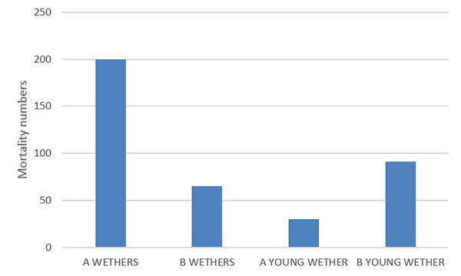
(Graph 3: mortalities from daily report day 25)
Graph 3 shows a larger proportion of the mortalities (200 sheep) were recorded as ‘A’ wethers with an average weight of 60 kg. This class had a higher percentage of deaths compared to the other classes of sheep. There was an overall mortality rate of 7.44 per cent for this class loaded in Adelaide. On day 23, 121 of the 192 mortalities were in the A class wethers.

Graph 4 – Mortality numbers by deck for sheep (Consignment A)
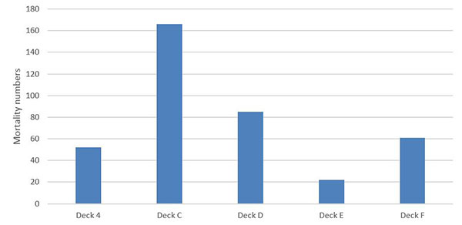
(Graph 4: mortalities from daily report day 25)
Graph 4 shows the mortality numbers by deck. A large proportion of the mortalities (166 sheep) occurred on Deck C.
To investigate any correlation between class, deck and mortality, the department compared the total mortality in the two classes housed on Deck C (A wethers, 60kg average weight loaded; and MW lambs, 40kg average weight). The mortalities in A class wethers on Deck C were 168 out of 1871, (9 per cent) compared with the MW lambs 32 out of 3819 (0.84 per cent), noting that the MW lambs loaded in Fremantle. Both classes of stock were unloaded at Shuwaikh Port in Kuwait.
The load plan indicates the remaining 816 A wethers from Adelaide were loaded onto Deck D. There are discrepancies between the load plan and the mortality report regarding the number of B wethers (average weight 52kg) that made up the remainder of the stock on this deck however the records demonstrate that A wethers suffered a mortality rate of 3.9 per cent on Deck D. The Consignment A average mortality was 2.15 per cent.
The data indicates the A wethers line of stock from Adelaide contributed to a large proportion of the mortalities related to heat stress. This is also consistent with the AAVs comments regarding heat stress in heavier sheep and comments that mortalities could not be attributed to any deck or pen.

Graph 5 – Total voyage mortality sheep (all consignment)
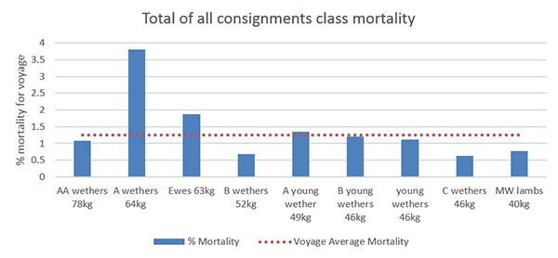
(Graph 5: figures loaded sheep from HSRA and deck mortality from daily report day 25)
Other heavier sheep (2 034 AA 73kg wethers and 2 240 63kg ewes) in different consignments on the same voyage recorded an average mortality of 1.08 and 1.87 per cent respectively. When combined, these heavier sheep recorded a total mortality rate of 1.5 per cent that is higher than the total voyage average of 1.24 per cent.

Australian Maritime and Safety Authority Evaluation of the Vessel
Consistent with Marine Order 43 AMSA did not investigate the vessel operation as the overall sheep mortality rate on this voyage was 1.24 per cent and below the reportable level of 2 per cent.
Subsequently the vessel has completed 11 livestock export voyages. Six of these carried sheep to the Middle East and one of these voyages in August 2017 resulted in a reportable mortality rate of 3.76 per cent. This voyage has been investigated and findings published in Mortality Report #69.

Conclusions
The main cause of mortalities in Consignment A was heat stress commencing on day 19 and becoming extreme on days 22 and 23. At the time of the heat event, the AAV withdrew food and prioritised watering thereby reducing metabolic heat to the extent possible.
The highest rates were in the A Class wethers (64kg) loaded in Adelaide suffering a 7.44 per cent mortality rate. All other classes of sheep experienced mortalities below the reportable level even though they experienced the same environmental conditions, indicating this particular class was susceptible to heat stress.
Sheep were sourced for both Adelaide consignments from 67 vendors and then drafted by class and weight after arrival in the RP suggesting there was not an underlying health issues with animals sourced from a particular property.
Following regulatory action taken in response to Mortality Report 69, the department has subsequently cancelled the livestock export licence of Emanuel.

Appendix 1: Summary of daily mortalities
Day of voyage | Cumulative mortalities (number of sheep) | Daily mortalities (number of sheep) | Cause of daily mortalities recorded by the AAV
1 | 0 | 0 | Nil
2 | 0 | 0 | Nil
3 | 3 | 3 | 3 inanition
4 | 5 | 2 | 1 salmonella; 1 unrecorded
5 | 6 | 1 | 1 salmonella
6 | 11 | 5 | 2 inanition; 1 ruptured penis; 1 rumenitis; 1 salmonella
7 | 14 | 3 | No post mortems (in port)
8 | 16 | 2 | 2 gastritis
9 | 19 | 3 | 1 LI enteritis; 1 gastritis; 1 liver parisites not eating well
10 | 21 | 2 | 1 LI enteritis with excess fat and fatty liver; 1 gastritis
11 | 22 | 1 | Post mortems are showing three patterns of death, primary inanition, secondary inanition as a complication to E. coli and secondary inanition as a complication of Salmonella
12 | 23 | 1
13 | 30 | 7
14 | 32 | 2
15 | 39 | 7
16 | 41 | 2
17 | 49 | 8
18 | 55 | 6 | Euthanised due to lameness prior to discharge
19** | 59 | 4 | 4 unrecorded
20 | 66 | 7 | 7 unrecorded
21*** | 71 | 5 | 5 unrecorded
22 | 98 | 27 | 27 unrecorded
23**** | 290 | 192 | 192 heat stroke
24***** | 339 | 49 | 49 unrecorded
25 | 386 | 47 | 47 unrecorded
(Appendix: mortalities from daily report day 25 - no correction for sheep count discrepancies or mortalities that occurred after the last daily report period)
* Live Export, Project LIVE.116. Developing of a heat stress risk management model, Maunsell Australia Pty td, Published by Meat & Livestock Australia Ltd December 2003
** Unloading commenced in Oman, Port of Muscat
*** Departed Oman
**** At anchor in Kuwait
***** Unloading commenced in Kuwait, Port of Shuwaikh

