Independent Observer summary report on MV Ocean Ute

Cattle exported to Vietnam in July 2022
December 2022

Voyage summary
Livestock: 3,581 cattle.
Vessel: MV Ocean Ute.
Loading location and date: Townsville, 5 July 2022.
Vessel departure date: Townsville, 5 July 2022.
Discharge location and dates: Hon La, Vietnam, from 18 July 2022 to 20 July 2022.
Voyage length: 16 days.
Independent Observer: Boarded at Townsville and remained onboard until completion of discharge.
Voyage mortality rate: 0.28% (10 mortalities). These mortalities are unlikely to be linked to any systemic failure by the exporter.
Notifiable mortality rate required to trigger a mortality investigation: 0.5% or 3 animals (whichever is greater).

Summary of observations
This report summarises key observations of the implementation and effectiveness of exporter arrangements to ensure the health and welfare of livestock. The report has been approved by the observer who accompanied the voyage.

Exporter documentation
The observer reported no issues regarding exporter documentation.

Loading
Based on observations made during this voyage, the exporter arrangements during loading were appropriate and effective in managing livestock health and welfare.

Personnel
Based on observations made during this voyage, the exporter arrangements relating to personnel were appropriate and effective in managing livestock health and welfare.

Daily routine
Based on observations made during this voyage, the exporter arrangements relating to the daily routine were appropriate and effective in managing livestock health and welfare.

Feed and water
Based on observations made during this voyage, the exporter arrangements relating to feed and water were appropriate and effective in managing livestock health and welfare.

Ventilation
Based on observations made during this voyage, the exporter arrangements relating to ventilation were appropriate and effective in managing livestock health and welfare.

Pen conditions
The observer noted that:
- There were occasional water leaks caused by leaking hose connections or overflowing water troughs. These were repaired quickly by the crew with no impact on pen conditions or animal health and welfare observed.
- Some gates had been removed between pens, leaving exposed hinges. This did not lead to any observed animal health and welfare issues.

Health and welfare
The stockperson reported that:
- Post-mortems were conducted on all mortalities except those occurring on the day of discharge.
- One post-mortem identified respiratory issues as the likely cause of death.
- No abnormalities were detected during the remaining post mortems.
- Treatments were administered to a number of cattle for nasal discharge, lameness, limb injuries and infections.

Discharge
Based on observations made during this voyage, the exporter arrangements during discharge were appropriate and effective in managing livestock health and welfare.

Department actions
No adverse animal health and welfare outcomes arising from exporter arrangements were observed, and no regulatory action was taken for this voyage.

Representative photographs of voyage
Day 2 Cattle in pen — gate hinges exposed  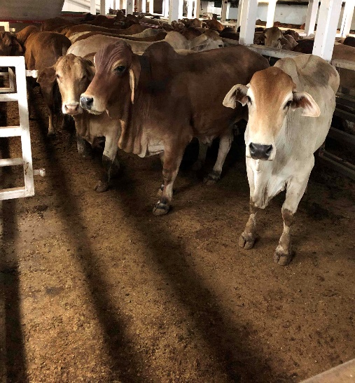 | Day 5 Cattle in pen — no issues identified  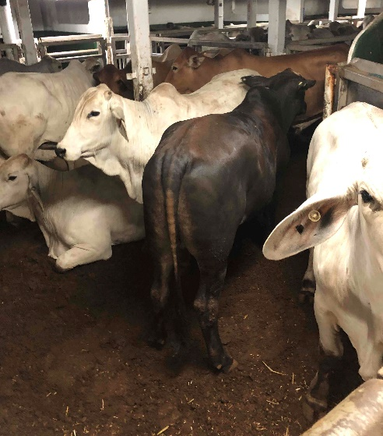
Day 7 Cattle in pen — no issues identified  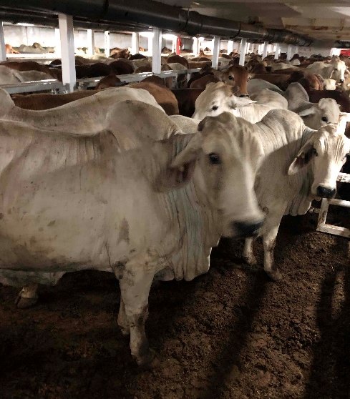 | Day 9 Cattle in pen — gate hinges exposed  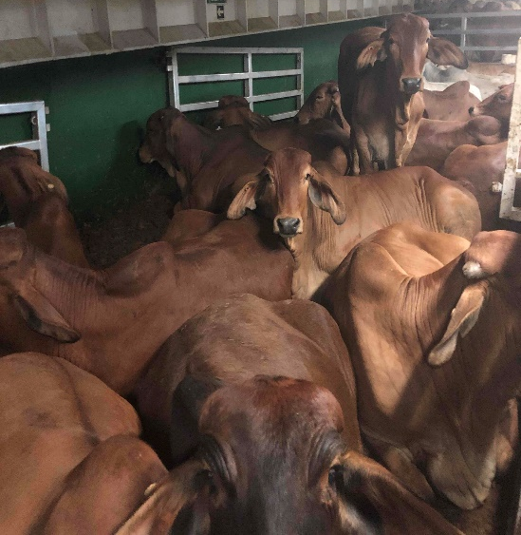
Day 11 Cattle in pen — no issues identified  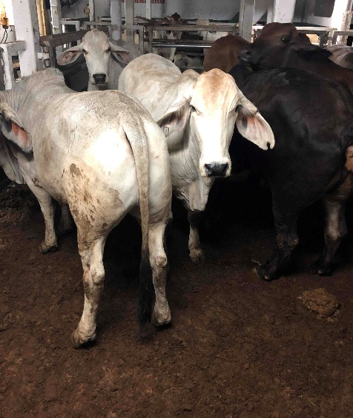 | Day 13 Cattle in pen — no issues identified  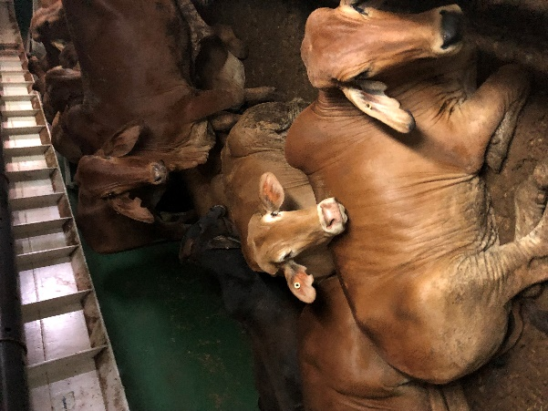

Acknowledgement of Country
We acknowledge the Traditional Custodians of Australia and their continuing connection to land and sea, waters, environment and community. We pay our respects to the Traditional Custodians of the lands we live and work on, their culture, and their Elders past and present.
© Commonwealth of Australia 2022
Unless otherwise noted, copyright (and any other intellectual property rights) in this publication is owned by the Commonwealth of Australia (referred to as the Commonwealth).
All material in this publication is licensed under a Creative Commons Attribution 4.0 International Licence except content supplied by third parties, logos and the Commonwealth Coat of Arms.
The Australian Government acting through the Department of Agriculture, Fisheries and Forestry has exercised due care and skill in preparing and compiling the information and data in this publication. Notwithstanding, the Department of Agriculture, Fisheries and Forestry, its employees and advisers disclaim all liability, including liability for negligence and for any loss, damage, injury, expense or cost incurred by any person as a result of accessing, using or relying on any of the information or data in this publication to the maximum extent permitted by law.

